



USER

GUIDE



USER GUIDE

N EW D E L H I

S EP T EM B ER 2 0 2 2

Table of Contents

Introduction 3

1. Home 4

2. About 5

3. Information Kiosk 6

4. Contact 7

5. Login 8

5.1 At a Glance 9

# Introduction

The **Girls Empowering Girls** (GEG) **Management Information System** (MIS) is developed as a web-based MIS system that includes data collection, transaction management and reports generation modules to automate beneficiary management in the GEG program. The platform has tools developed for various processes including pre-registration, registration, cash transfers, mentoring, referral and grievance/complaint management. The platform will comprise of various independent modules. Below is the list of all the modules.

1. Home
2. About
3. Information Kiosk
4. Contact
5. Login

5.1 At a Glance

5.2 Pre-Registration

5.3 Participant Registration

5.4 Cash Transfer

5.5 Admin

5.6.1 Summary

5.6.2 Manage Area

5.6.3 Manage Cohort

5.6.4 Manage School

5.6.5 Manage Master List

5.6.6 Manage User

5.6.7 Manage Resource

5.6.8 Manage Log

5.6.9 Audit Trail

5.7 Reports

Below chapters explains the above modules in details.

# Home

The **GEG MIS** platform is a web-based system which can be accessed through a web browser (recommended browser - Google Chrome latest version). Enter URL <https://itmcloud.org/geg/dashboard/> in the web browser. The first page you will get to view is the home page. The home page is the landing page of the GEG MIS Portal and has the following options available to navigate through all the modules of the portal - **About**, **Information Kiosk, Contact** and **Login**.

This module presents the dynamic key facts along with a background image which keeps on changing in fixed interval of time (see below figure).

# About

Click on the **About** menuoption from the home page to navigate to the module. This module presents the detailed information about **Girls Empowering Girls** programme and its objectives.

# Information Kiosk

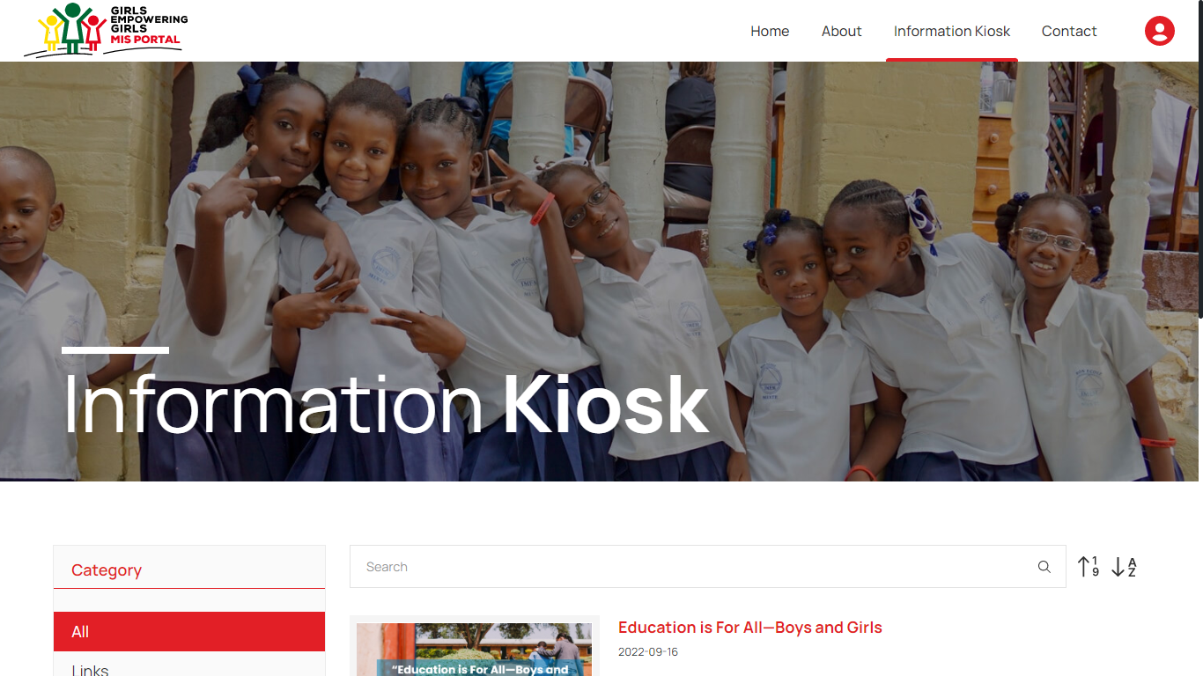Click on the **Information Kiosk** menuoption from the home page to navigate to the module. This module presents the reference documents relevant to the GEG MIS portal. You will be able to view the **Resources** grouped by category. You can either view **All** the resources or filter them by category. You can also **Search** resources by entering text in search bar available at the top right corner. Additionally, you can **Sort** the resources in alphabetical order and in the order of its date of creation by clicking on the respective sorting icons (see below figure).

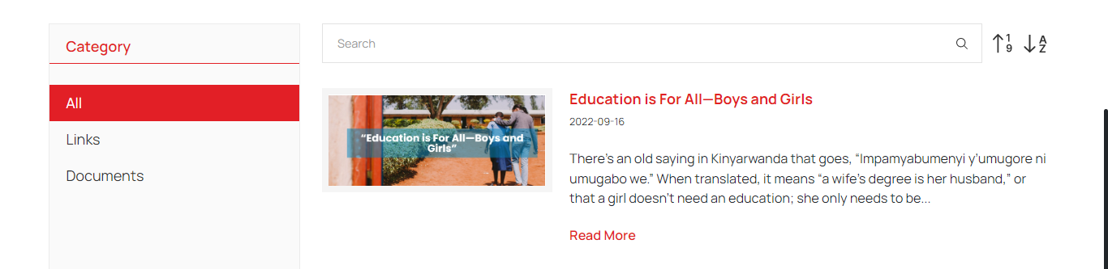Click on **Read More** button available with each resource to read full description of that resource (see below figure).

# Contact

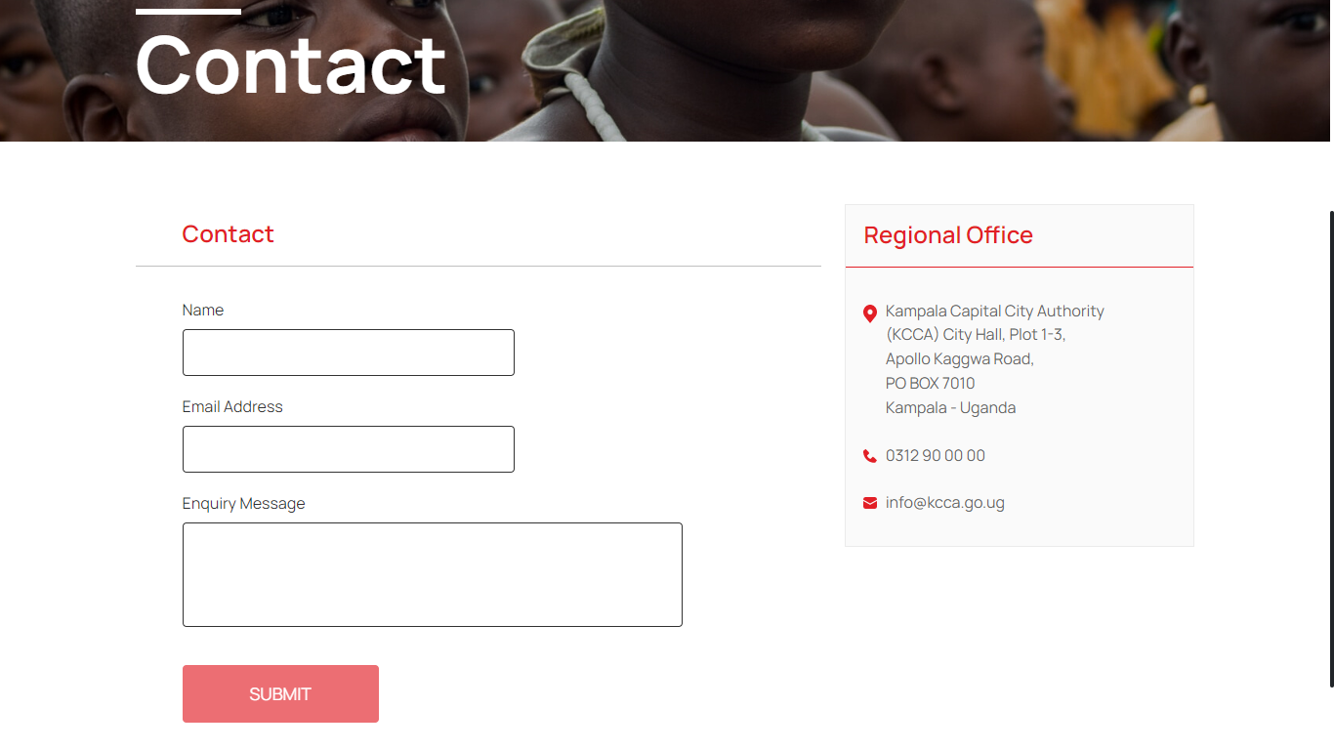Click on the **Contact** menuoption from the home page to navigate to the module. This module provides the Address and Contact details of KCCA Regional Office. To send enquiry message to KCCA officials, enter **Name**, **Email** **Address**, **Enquiry Message** and click on Submit (see below figure).

# Login

Click on the **Login** option from the home page to enter the credentials and get access to the other modules of the portal based on your roles and permissions assigned by the administrator.

|  |
| --- |
| *“This user guide is developed for the Administrator Role. The admin is able to access all the modules of the GEG MIS Portal whereas the modules and permissions will vary based on the other user roles.”* |

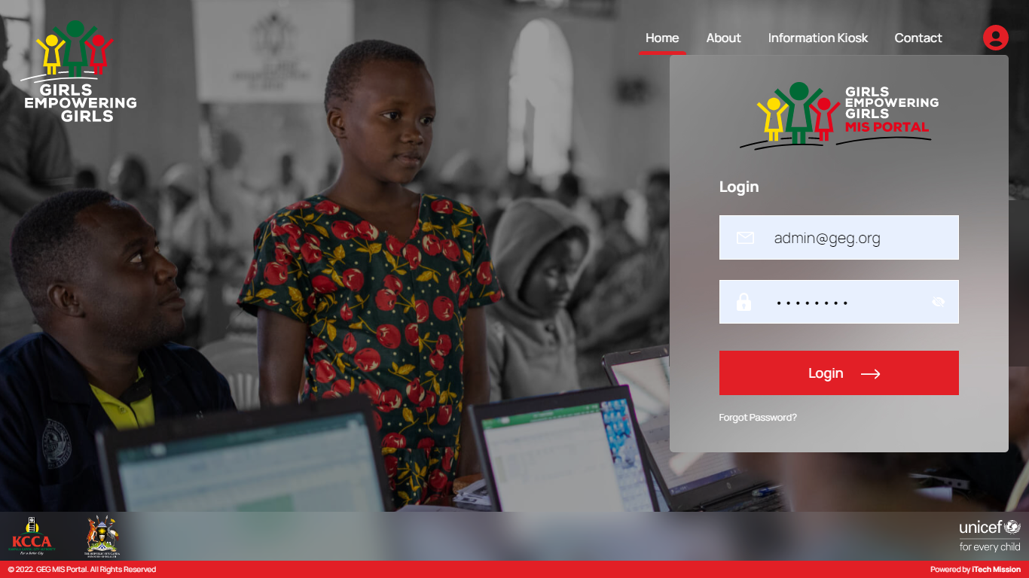Enter valid **Email ID** & **Password** and click on **Login** (see below figure).

## At a Glance

## Admin

This user manual is developed to help the system administrator to understand the use of Admin application and its modules. This application will only be accessed to the users with valid login credentials through login process.

The Admin comprises of various data management modules. These modules allow the creation and management of the master data. Following are the data management modules -

* 1. Summary
  2. Manage Area
  3. Manage Cohort
  4. Manage School
  5. Manage Master List
  6. Manage User
  7. Manage Resource
  8. Manage Log
  9. Audit Trail

Let us understand and learn on how to use these modules.

### 5.2.1 Summary

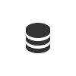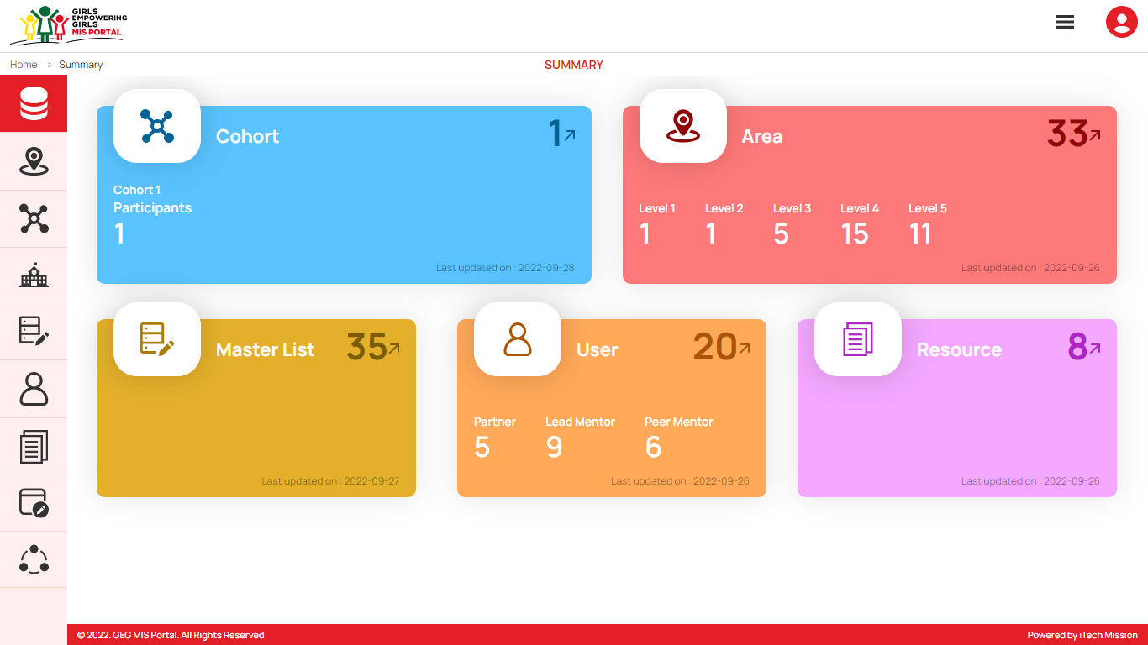The first module after successful login is **Summary.** You can also access this module by clicking on the **Summary** menu option in the left panel (see below figure).

The Data summary module depicts the following information.

1. **Cohort**

The first widget shows the total count of cohorts and the count of participants available in the database and the last date when the cohort and participant list were updated.

1. **Area**

The next widget shows the total count of geographical areas along with the count of areas which falls under area level 1 to level 5 available in the database and the last date when the area details were updated.

1. **Master List**

The first box in next row shows the total count master list available in the database and the last date when the master list was updated.

1. **Manage User**

The next box shows the total count of users along with count of users by user role partner, peer mentor and lead mentor available in the database and the last date when the user details were updated.

1. **Manage Resource**

The last box shows the total count of resources available in the database and the last date when the resources were updated.

### 5.2.2 Manage Area

****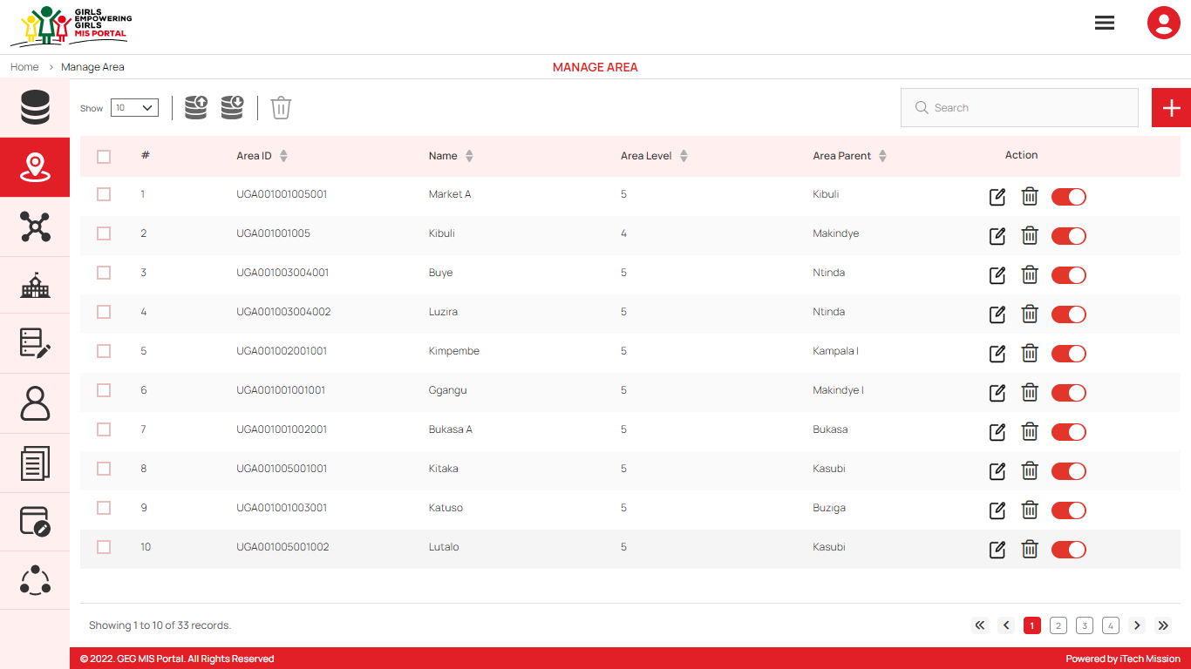To access this module, click on the **Manage** **Area** menu option in the left panel. This module allows to manage the Area master list. You will have options to export and import an area template, add new area, view the list of existing areas, sort the list, search area from the list, delete, edit update existing areas (see figure below).

#### Export Area

By clicking on the **Export** button, a pop-up window appears (see below figure). You can download the empty area template and area list available in the database.

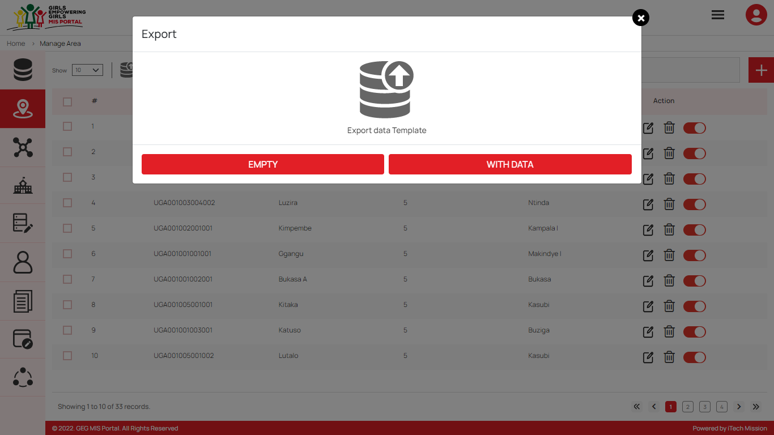You can use this option to create an area structure. Below is the area structure that you will find in the area template.

|  |  |
| --- | --- |
| **AreaID** | A unique area identification that associates the area to its map. |
| **AreaName** | Area Name assigned to an area. |
| **AreaLevel** | The level number assigned in the area hierarchy. |
| **ParentAreaID** | AreaID of the parent area. |

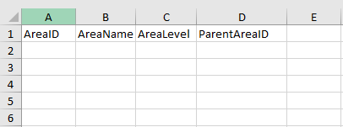By clicking on the **Empty** button, you can download an empty area template (see below figure). The area list is imported and exported in the CSV (Comma Separated Value) file format.

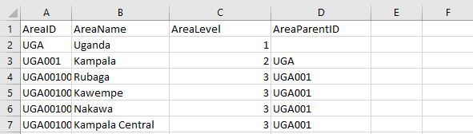Click on the **With Data** button of the download box to download the area list available in the database (see below figure).

#### Import Area

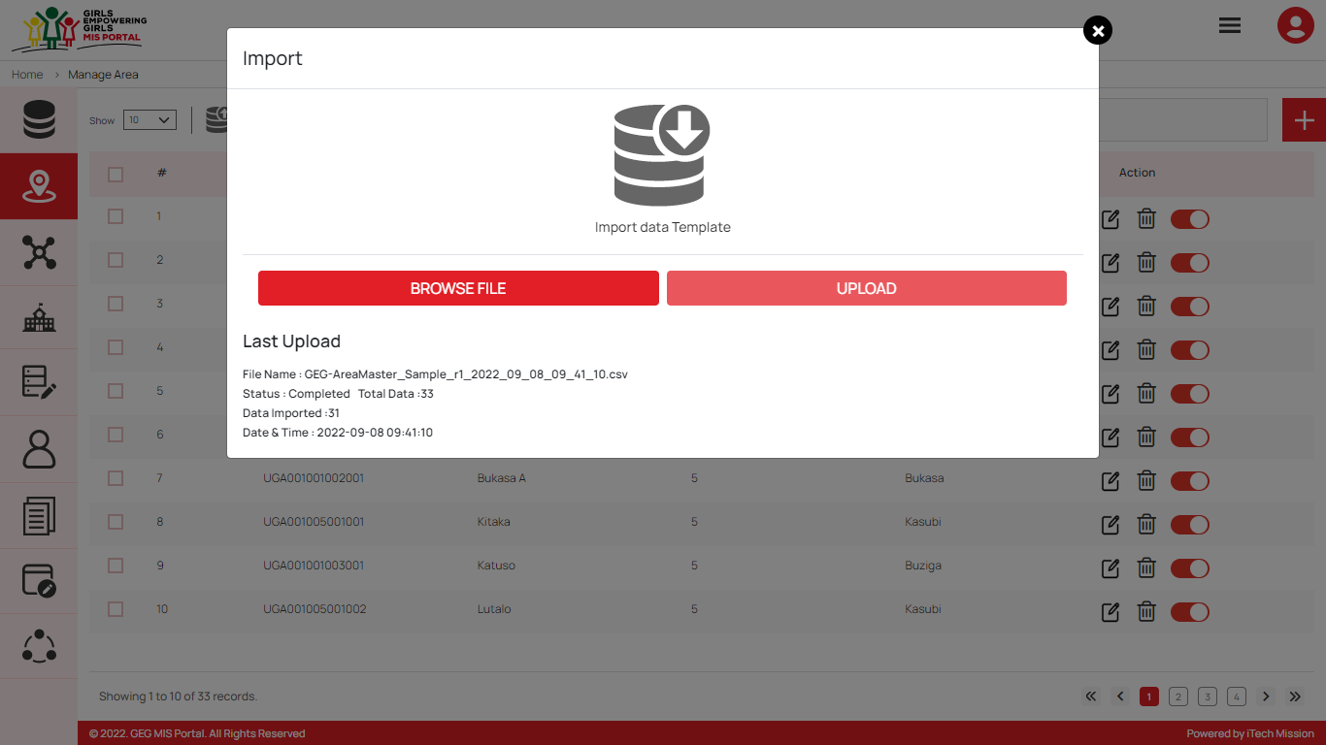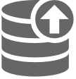By clicking on the **Import** button, a pop-up window appears (see below figure). You have the option to browse the file and upload the area list into the database.

To upload the area into the database first enter the area structure in the template as explained above and then click on the **Browse File** button to select the template. Now, click on the **Upload** button to start the import process. During the import process, the records which contains blank entries, entries with special characters and duplicate entries are not imported in the database.

A Last Upload import summary provides the count of records which were Duplicate, Failed, successfully inserted and Updated into the database out of the total records.

#### Add Area

****Click on the **Plus** button available to the right side of the page to **add** a new area (see figure below). Enter the following details to add a new area.

* Select **Parent Area**
* Enter **Area ID**
* Enter Area **Name**

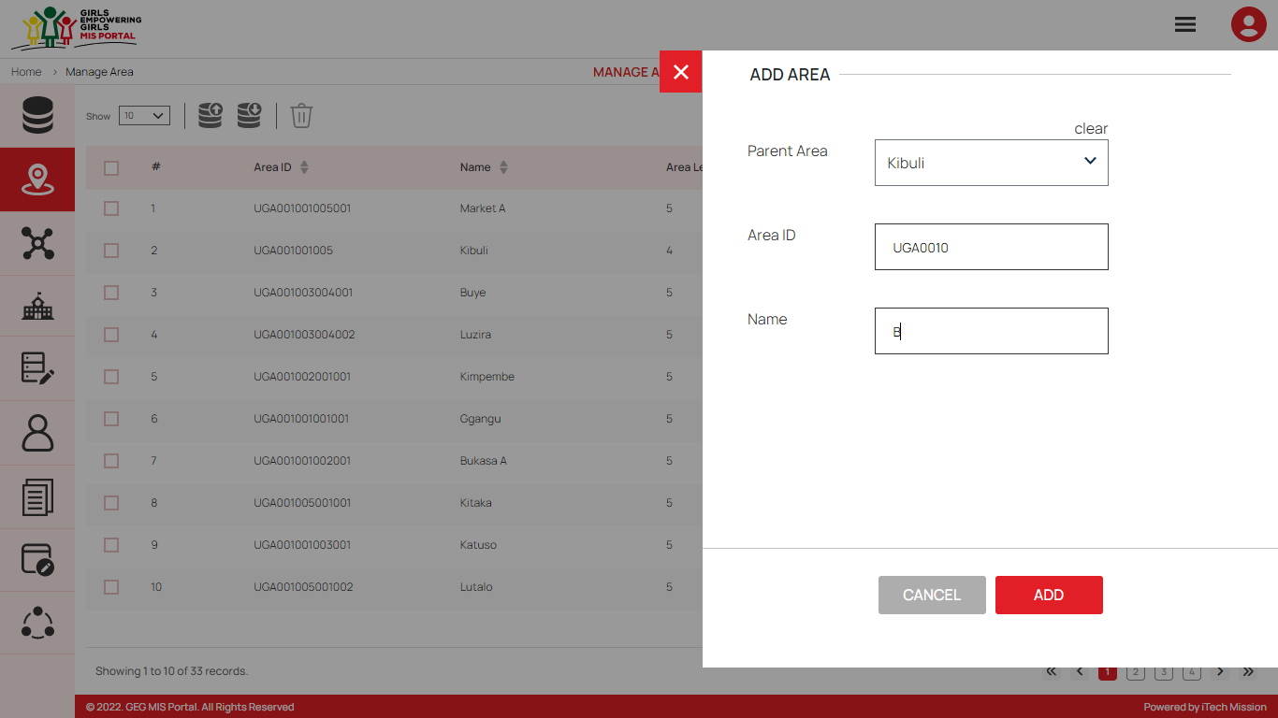All the details are mandatory to be entered. Click on the **Add** button to save and confirm. You can now view the new area added in the area list.

You can edit an area by clicking on the **Edit** button from the Action column. When you click on the edit button the edit area form will open where you can edit any detail of the area. Edit the required detail and click on the Update button to save and confirm.

You can delete an area by clicking on the **Delete** button from the Action column. When deleting a Parent area, an error message will appear stating “This area has associated child areas.”. When deleting an area, a confirmation popup will appear to confirm deletion. If clicked Yes, the selected record will be deleted.

Click on the **Status** button to enable or disable the specific area. The disabled area will not be shown in the list of area in the overall application.

### 5.2.3 Manage Cohort

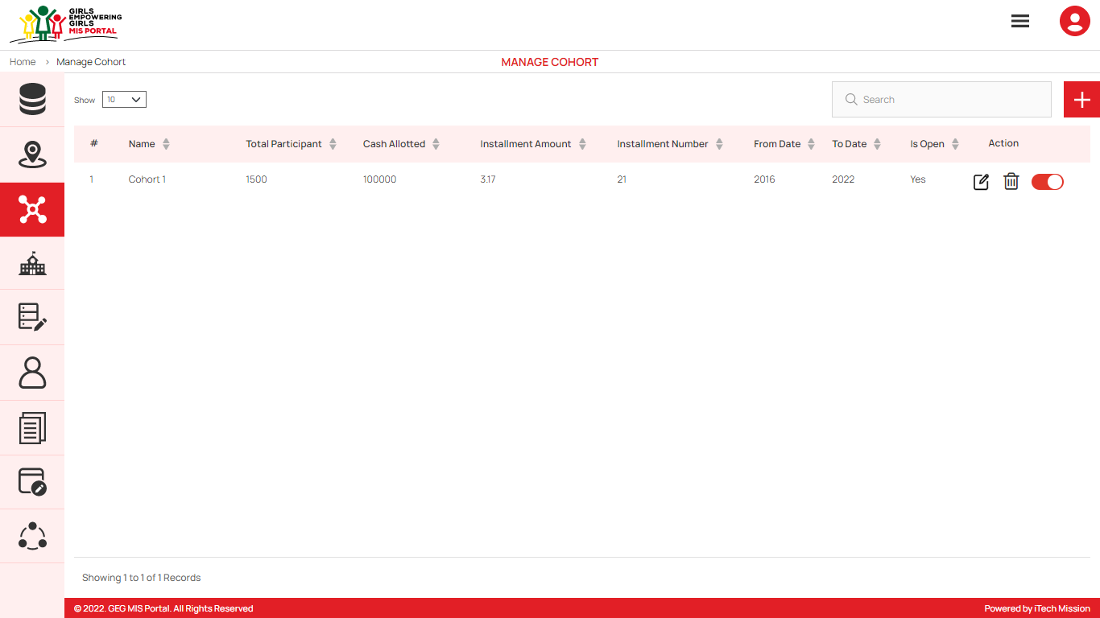To access this module, click on the **Manage** **Cohort** menu option in the left panel. This module allows to manage the Cohort master list. You will have options to add new cohort, view the list of existing cohorts, sort the list, search cohort from the list, delete, edit and enable/disable existing cohorts (see figure below).

#### Add Cohort

Click on the **Plus** button available to the right side of the page to **add** a new cohort (see figure below). Enter the following details to add new cohort.

* Select **Area**
* Enter cohort **Name**
* Select cohort **Duration**
* Enter **Number of Installment**
* Enter **Total Participant**
* Enter **Cash Allotted**
* Enter **Installment Amount**
* Enter **Cohort Description**
* Select **if cohort Is Open**

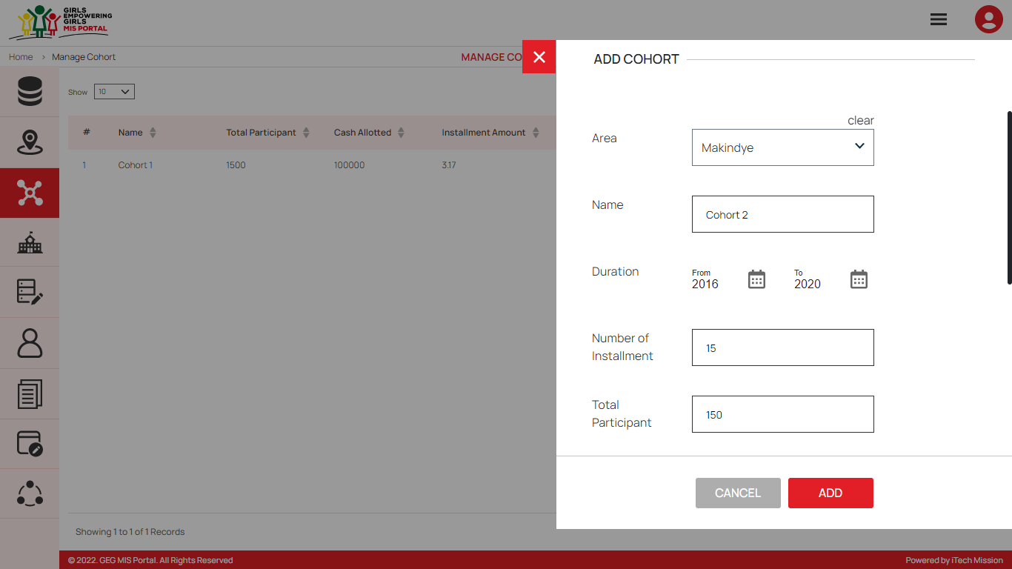All the details apart from cohort description are mandatory to be entered. Click on the **Add** button to save and confirm. You can now view the new cohort added in the cohort list.

You can edit a cohort by clicking on the **Edit** button from the Action column. When you click on the edit button the edit cohort form will open where you can edit any detail of the cohort. Edit the required detail and click on the Update button to save and confirm.

You can delete a cohort by clicking on the **Delete** button from the Action column. When deleting a cohort, a confirmation popup will appear to confirm deletion. If clicked Yes, the selected record will be deleted.

Click on the **Status** button to enable or disable the specific cohort. All the records of the disabled cohort will not be shown in the overall application.

### 5.2.4 Manage School

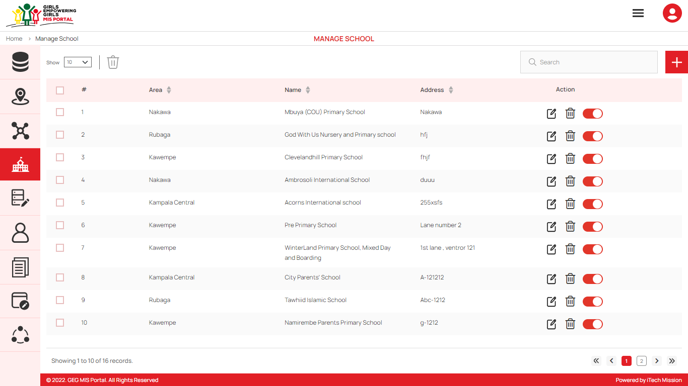To access this module, click on the **Manage** **School** menu option in the left panel. This module allows to manage the school master list. You will have options to add new school, view the list of existing schools, sort the list, search school from the list, delete, edit and enable/disable existing schools (see figure below).

#### Add School

****Click on the **Plus** button available to the right side of the page to **add** a new school. Enter the following details to add a new School.

* Select **Area**
* Enter **Name** of the school
* Enter **Address** of the school

All details are mandatory to be entered. Click on the **Add** button to save and confirm. You can now view the new school added in the list of school.

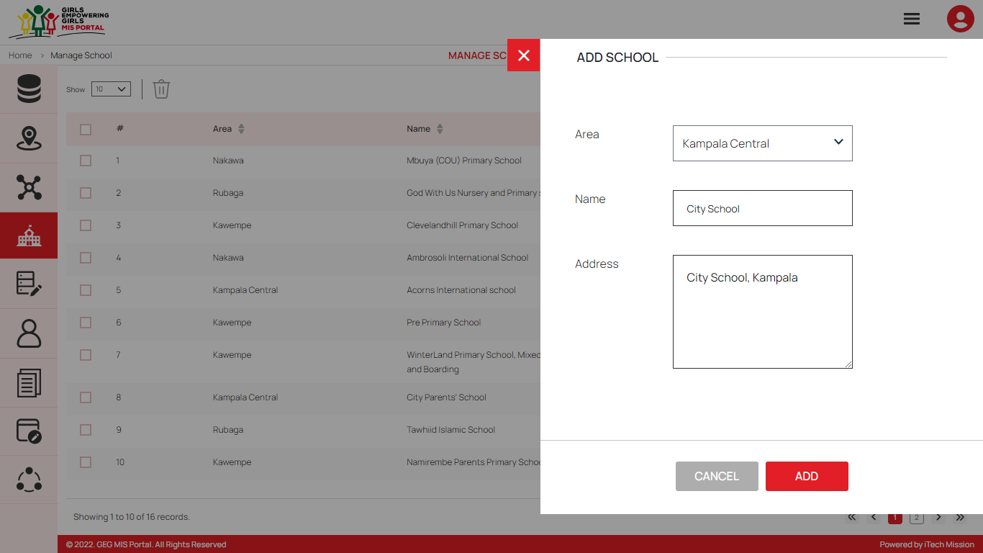You can edit a school by clicking on the **Edit** button from the Action column. When you click on the edit button the edit school form will open where you can edit any detail of the school. Edit the required detail and click on the Update button to save and confirm.

You can delete a school by clicking on the **Delete** button from the Action column. When deleting a school, a confirmation popup will appear to confirm deletion. If clicked Yes, the selected record will be deleted.

Click on the **Status** button to enable or disable the specific school. The disabled school will not be shown in the school list overall application.

### 5.2.5 Manage Master List

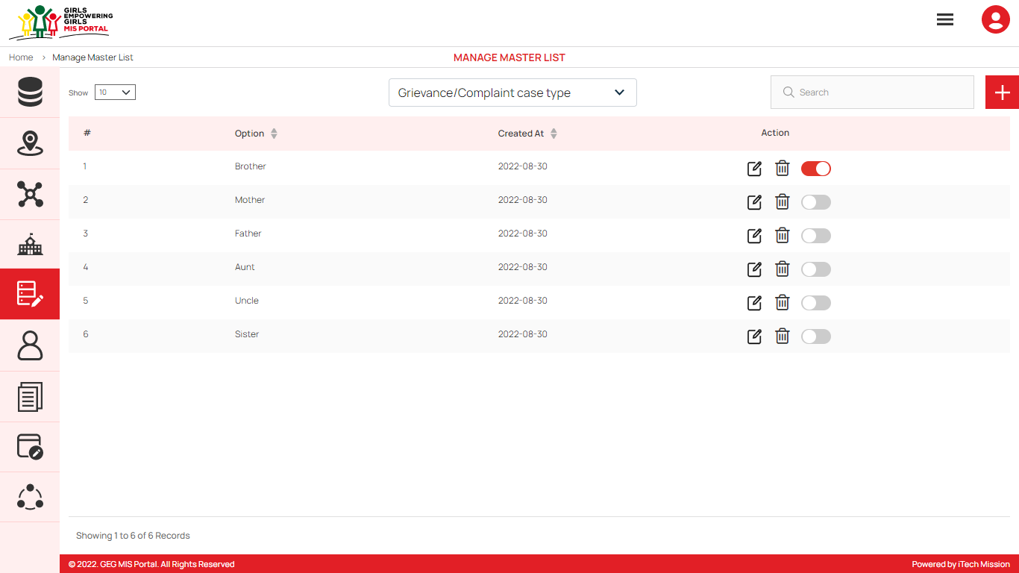To access this module, click on the **Manage** **Master List** menu option in the left panel. This module allows to manage the master list of type Grievance/Complaint case, Referral, Vulnerability, Caretaker Relationship, Caretaker Occupation, Biological Parents Alive Status, Living Status and Caretaker Responsibilities. You will have options to add new elements to all the types of master lists, view the list of existing master list filtered by type, sort each list, search elements of selected type from the list, edit and enable/disable existing elements of selected type from the list (see figure below).

#### Add Master List

Click on the **Plus** button available to the right side of the page to **add** a new element (see figure below). Select master type and enter option to be added in the master list of selected type. Click on the **Add** button to save and confirm add new element to the master list

You can edit an element from the master list by clicking on the **Edit** button from the Action column. When you click on the edit button the edit master list form will open where you can edit option of selected master type. Edit the required detail and click on the Update button to save and confirm.

You can delete an element by clicking on the **Delete** button from the Action column. When deleting an element, a confirmation popup will appear to confirm deletion. If clicked Yes, the selected record will be deleted.

Click on the **Status** button to enable or disable the specific element. The disabled element will not be shown in the dropdown option of selected master list overall application.

### 5.2.6 Manage User

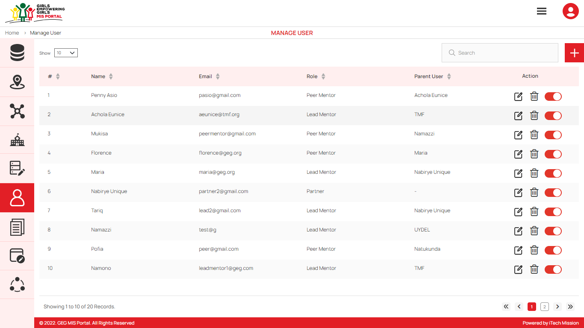To access this module, click on the **User** menu option in the left panel. This module allows to manage the User master list. You will have options to add new users, view the list of existing users, search users from the list, edit and enable/disable existing users (see figure below).

#### Add User

****Click on the **Plus** button available to the right side of the page to add new user (see figure below).

You can create a new user and assign them one of the roles.

1. Program Manager
2. Program Co-Ordinator
3. Program Officer
4. Lead Partner
5. Partner
6. Lead Mentor
7. Peer Mentor

Enter the following details to create a new user.

* Select **Role**
* Select **Partner** (Incase the selected role is Lead Mentor)
* Select **Lead Mentor** (Incase the selected role is Peer Mentor)
* Select **Area**
* Enter **Name**
* Enter **Email ID**
* Enter **Password**

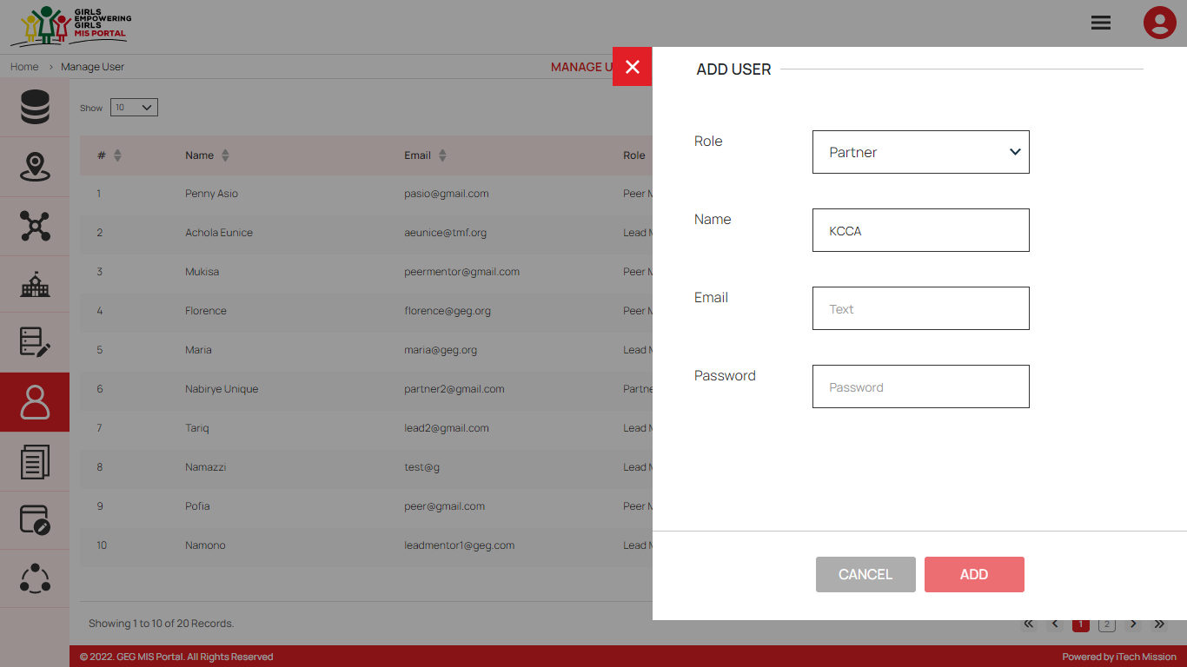Click on the **Add** button to save and confirm. You can now view the new user added to the list.

You can edit a user by clicking on the **Edit** button from the Action column. When you click on the edit button the edit user form will open where you can edit any detail of the user. Edit the required detail and click on the Update button to save and confirm.

You can delete a user by clicking on the **Delete** button from the Action column. When deleting a user, a confirmation popup will appear to confirm deletion. If clicked Yes, the selected record will be deleted.

Click on the **Status** button to enable or disable the specific school. The disabled user will not be shown in the user list overall application.

### 5.2.7 Manage Resources

To access this module, click on the **Resource** menu option in the left panel. This module allows to manage the Resource master list. You will have options to add new resource, view the list of existing resources, search resource from the list, edit existing resource from the list (see figure below).

#### Add Resource

****Click on the **Plus** button that is available to the right side of the page to Add a new resource (see figure below). Enter the following details to create a new resource.

* Enter Resource **Title**
* Enter **Description**
* Select Resource **Type**
* Upload document (Incase the resource type is document and template)
* Enter URL (Incase the resource type is URL)
* Upload Resource Image

Click on the **Add** button to save and confirm. You can now view the new resource added to the list.

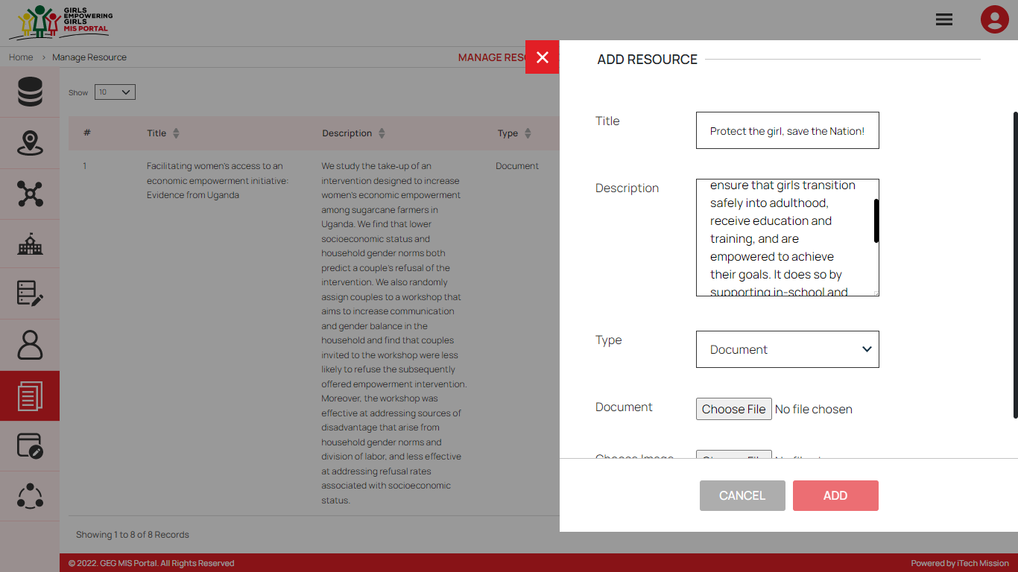You can edit a resource by clicking on the **Edit** button from the Action column. When you click on the edit button the edit resource form will open where you can edit any detail of the resource. Edit the required detail and click on the Update button to save and confirm.

You can delete a resource by clicking on the **Delete** button from the Action column. When deleting a resource, a confirmation popup will appear to confirm deletion. If clicked Yes, the selected record will be deleted.

Click on the **Status** button to enable or disable the specific resource. The disabled resource will not be shown in the Information Kiosk module of User Interface application.

### 5.2.8 Manage Log

To access this module, click on the **Manage** **Log** menu option in the left panel. This module allows to manage the Data Import Log master list. You will have options to view the list of existing logs, download and view log reports and delete selected records (see figure below).

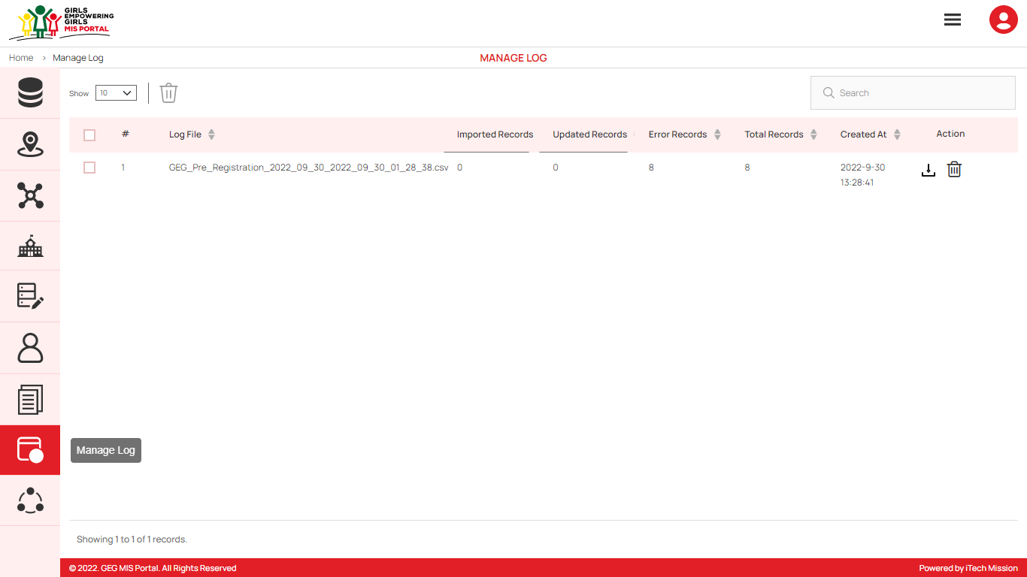A log will be generated whenever any data template will be imported into the database. A list of import logs is shown on this page where each import log is shown as a row. You can see the file name of each import log along with the log summary that includes: count of records imported, count of records updated, count of error records, total records available in the import file and date & time of the import. You also have the options to download the log file in order to view the reason of error records, or delete the log file. The log file will be downloaded in CSV format.